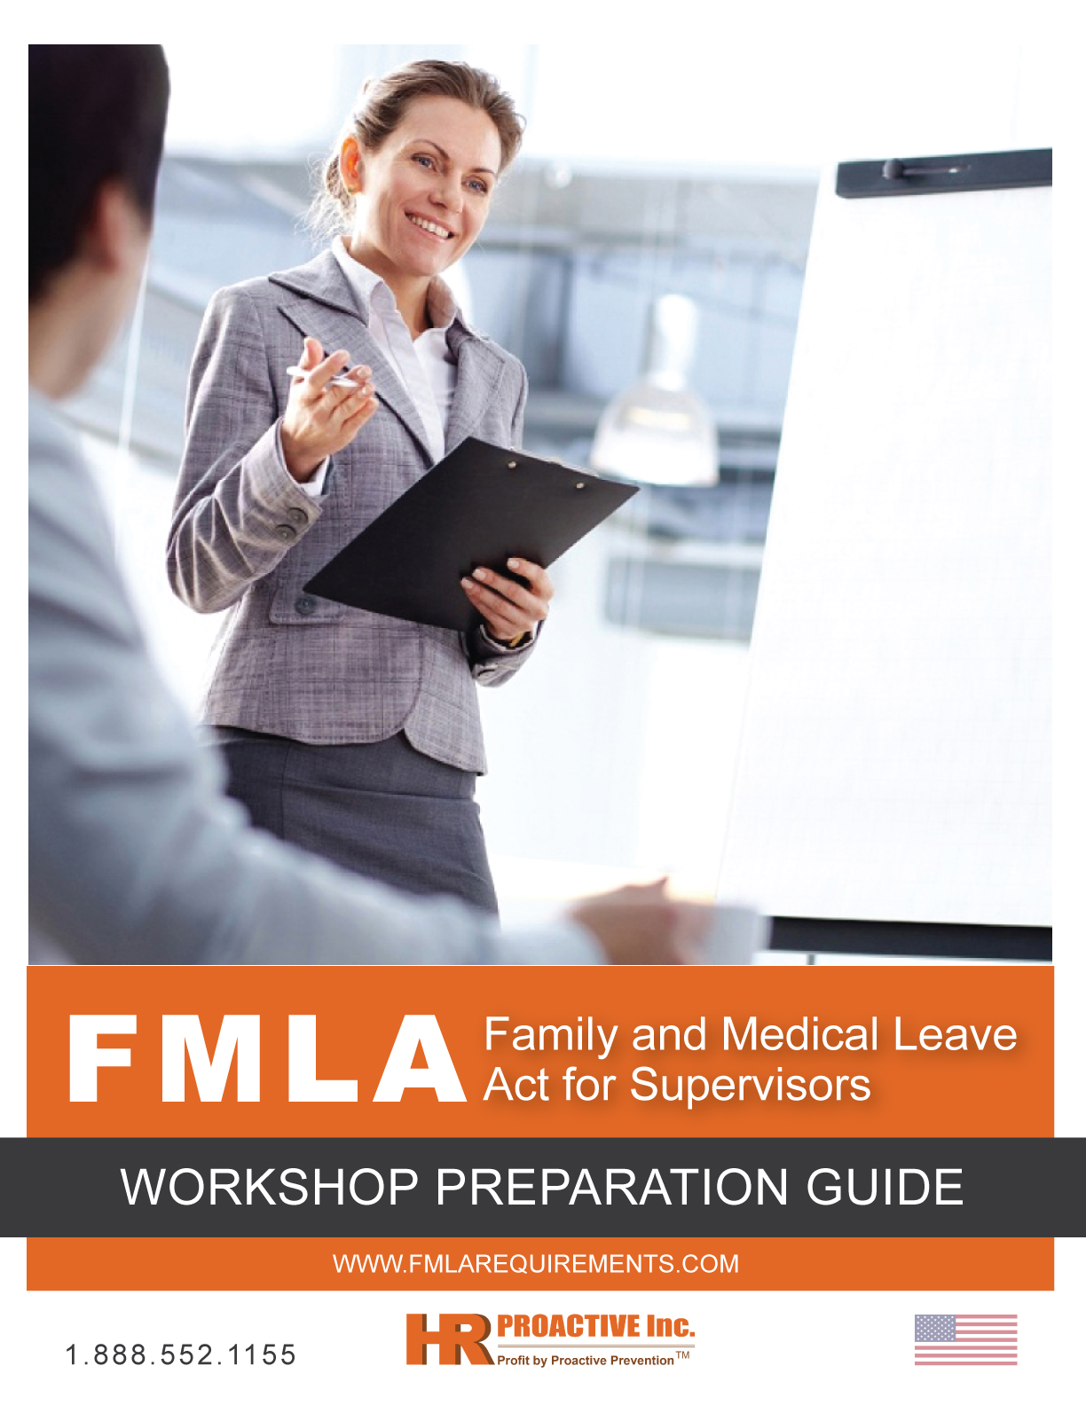

Disclaimer

The information contained in this training kit is for informational purposes only. If you wish to apply concepts or ideas contained in this video, you are still fully responsible for your actions. In any event, HR Proactive Inc. and assigned users of this training kit shall in any event be held liable to any party for damages of any kind arising directly or indirectly from any use of this material, which is provided as is, and without warranties. Users of this training kit are responsible for how they choose to utilize its content, and HR Proactive Inc. assumes no liability for the use, alteration or misuse of the information contained herein.

As in all cases, users should always exercise their own due diligence on any viewed material to form their own conclusions and best judgments. The training concepts included in this training kit are not intended to be an exhaustive presentation of all problems and issues arising out of any topic. This training kit may also not be an accurate reflection of particular circumstances or equipment at an individual worksite or facility. Ensure you provide work- and job-specific training to all workers in compliance with health and safety legislation in your jurisdiction. Users who intend to take, or refrain from taking, any action based on information contained herein should first consult with qualified legal counsel or other appropriate professional advisor.

TABLE OF CONTENTS

Workshop Overview 1
Workshop Objectives 1
How to Use the Workshop Preparation Guide 1
Resources 1
Workshop Design 2
Optional PowerPoint Presentation 2
How to Customize the Workshop 2
Guide Format and Intent 3
Workshop Activity Outline 4
Target Audience 5
Workshop Preparation 5
Contacting Participants 5
Location Requirements, Materials and Equipment 5
Preparation Checklist 7
Suggested Agendas 8
Workshop Training Records 9
Measuring the Effectiveness of the Workshop 10
Measuring Participants Learning During the Workshop Session 10
Using the Evaluation/Feedback Form 10
Measuring Participant Learning After the Workshop Session 10
Workshop Facilitation Tips 11
Workshop Orientation 13
Introduction 13
Icebreaker 13
Participant Expectations 13
Housekeeping 14
Training Session Overview 15
PowerPoint Presentation Outline 15
Group Activity 1 16
Group Activity 2 17

Workshop Overview

Workshop Objectives

This guide presents a workshop design for education and training under the Family and Medical Leave Act (FMLA). The goal of the workshop is to give supervisors (participants) knowledge and information which they can understand and apply to process FMLA leaves for employees under their supervision. Presentation topics include:

- Employer Requirements and Responsibilities
- State Requirements for Employers
- Employee Eligibility
- Employee FMLA Leave Entitlement
- Employee FMLA Leave Entitlement: Military
- Medical Certification

How to Use the Workshop Preparation Guide

This guide is intended to be used by the workshop leader and should not be distributed to participants. It includes instructions for organizing and running a successful workshop.

It is recommended that the workshop leader become familiar with all material related to this workshop, including the Employee Handbook, PowerPoint and video DVD presentations, and supporting documents for example, handouts, poster, FMLA request form, etc.

Resources

The resources provided in this training kit can be used to assist employers with educating their supervisors and managers. Please review all material before distributing it to ensure that it is consistent with your own FMLA policies and any family and medical leave legislation relevant to your state or district.

The FMLA Employee Handbook is an educational resource for employees and can be distributed to all new employees and existing employees who have not received the required information as legislated under the FMLA. This handbook can also be used as an educational resource for Human Resources professionals and for managers/supervisors.

Workshop Design

The workshop offers the following features:

- Experiential learning that concentrates on developing knowledge and abilities through the experiences of the participants;
- Practical techniques that can be used on the job;
- The encouragement of learning from the knowledge and experiences of the workshop leader and participants;
- Employee handbook that provides reference material based on workshop concepts and techniques;
- FLMA 15-minute video DVD that can be shown as an introduction to, or to further emphasize workshop content; and
- A PowerPoint presentation that can be shown during the workshop and can be printed in handout format for participants to take away.

Optional PowerPoint Presentation

To use the PowerPoint presentation included with this kit, you will need:

- A computer with PowerPoint or a PowerPoint viewer installed; and
- A projector connected to the computer being used for the training session.

Note: It is important to test the functionality of your equipment before using the presentation to prevent delays.

How to Customize the Workshop

Customizing the workshop greatly enhances its value to participants. The following suggestions may be helpful:

- Before conducting the workshop, obtain information about the organization and the participants;
- Consult colleagues about FMLA issues to help build a larger base of knowledge and understanding of the topic;
- Customize the employee handbook for the organization and the particular participants attending;
- Alter the workshop outline and/or timing to reflect the needs of the audience. Use examples to which the audience can relate; and
- If it seems useful and time permits, allow discussion to continue beyond the recommended time frame. Always remember to process each activity thoroughly as it is important that participants are able to fully experience each activity.

A short video can provide an additional form of learning and be an effective change of pace from the experiential learning on which the remainder of the workshop is based. It is suggested that the video DVD be used as an introduction to the topic or to reinforce learning at the end of the workshop.

The workshop can also be customized to include training on the employer’s Family and Medical Leave (FMLA) policy.

There are two suggested agenda options outlined in the Suggested Agendas section of this guide which can be adjusted to suit the needs of the group and workshop leader.

Guide Format and Intent

The workshop presented in this guide highlights the major areas of FMLA in the workplace. The guide is divided into three parts:

Title | Description
Part I - Workshop Overview | Provides an overview of the workshop design, workshop preparation instructions, evaluations techniques and tips to facilitate the session.
Part II - Introduction to FMLA Workshop Activities | Provides the following:  - Detailed instructions on how to conduct each of the workshop activities  - All reference materials required to explain activities and to conduct lectures  - FMLA 15-minute video DVD  - All associated participant handouts, and PowerPoint presentation
Part III - Handouts | Provides workshop reference materials for reproduction and distribution to participants.  The PowerPoint slides included in this kit may be printed out as a handout. Select the option to print handouts and request 3 slides per page.

Although the workshop is complete, the design is flexible and can be customized to various groups and time frames. Its primary focus is to provide an environment that promotes learning through experience and encourages the transfer of these experiences and knowledge to the job.

Workshop Activity Outline

The workshop activities presented in Part II are divided into 7 lessons:
Lesson | Title | Description
1 | Workshop Orientation | Sets out the framework of the workshop, discusses the workshop objectives and agenda, describes responsibilities, and provides an opportunity for an icebreaker or group activity and the participants to identify their workshop expectations.
2 | Introduction to FMLA | Participants will review the learning objectives of the course and gain a general overview of the Family and Medical Leave Act. Participants will have an opportunity to complete Group Activity 1 on time management and the impact of illness to their daily routines.
3 | Process for the FMLA | Participants will examine the process for eligibility of FMLA leave, employee entitlement, and the responsibilities of the employer and supervisor.
4 | FMLA Policy | Participants will be introduced to the organization’s FMLA policy or given an opportunity to review the existing policy.
5 | Group Activity 2 | Participants will work through Group Activity 2 on following the FMLA process.
6 | Video | Participants will watch the FMLA video to receive additional detailed information on the topic which will help to reinforce learning concepts.
7 | Wrap-up and Evaluation | Provides an opportunity to summarize workshop contents and distribute handouts, quiz, including course evaluation sheet.

Target Audience

This workshop is intended for all supervisors that may have employees under their supervision needing FLMA leave. The course content within this workshop is a general overview of the FMLA and can be used for annual retraining of supervisors and for new hires. Ideal classroom size for Instructor-led training is no more than 25 participants.

Workshop Preparation

Contacting Participants

Participants should be contacted well ahead of the scheduled workshop date and notified of the following:

- Workshop leader’s name and position or trainer’s name and professional history
- Workshop location
- Date(s) and times
- Workshop goals and objectives
- A brief outline of the topics to be covered

Participants should also be advised that the workshop is based on an experiential learning model and involves the group’s active participation. They will be encouraged to work with new ideas and approaches and will be given an opportunity to practice what they have learned. (Refer to document - Workshop Details and Agenda)

Location Requirements, Materials and Equipment

It is important to choose a location that has access to the following:

- Ample wall space for posting group information
- Space that can accommodate a number of round tables and chairs
- Extra tables for workshop leader materials
- Refreshments
- Flipchart easel(s) and flipchart paper
- Laptop with media player
- Audio/visual equipment including overhead projector and PowerPoint projection system

All of the activities in Part II specify the materials that are required for each activity.

The Preparation Checklist on the following page lists the materials and equipment required for the workshop. Other equipment and materials not itemized may be necessary if the workshop leader alters the workshop design.

The workshop leader should arrive early to allow sufficient time for workshop preparation and set-up including checking materials, arranging the room and ensuring that equipment is functioning properly.

Preparation Checklist

- FMLA Employee Handbook(s) __________
- Pre-Post Assessment Quiz __________
- Workshop Sign-in Sheet __________
- Evaluation/Feedback Forms __________
- FMLA video DVD (optional) __________
- Assorted Handouts (form, poster, etc.) __________
- Overheads/PowerPoint Presentation (optional) __________
- Computer and projection system __________
If using PowerPoint presentation and/or video DVD.
- Participant Name tags __________
- Two or more newsprint flipcharts __________
- At least one flipchart easel __________
- Two packages of non-bleeding felt markers __________
- Masking tape __________
- Prepared flipcharts for activity instructions and
workshop orientation __________
- A watch or clock for timing activities __________
- Refreshments for breaks __________
(if appropriate)
- Water and glasses on tables __________

Suggested Agendas

Option 1:

This material can be used as recurrent training, by showing the FMLA video, handing out the employee handbook and leading a group discussion with a question and answer period. You can then follow-up with the Post Assessment Quiz and correct with participants.

Estimated time: 1 – 1.5 hours.

Option 2:

The material can be used as a workshop format and can be made interactive by showing the video with built-in quiz and having participants volunteer the answers.

Or, the video can be shown straight through and the quiz completed at the end. To make the workshop more experiential, two group activities have been added to the program to further discussions on FMLA leave of absence. There is also a PowerPoint presentation included with the program that can be shown for supervisory staff.

The following agenda is provided as an example, and should be modified to fit the individual needs of the group. Participants should be provided with an agenda approximately one week prior to the workshop.

Estimated time: 3 – 3.5 hours.

FMLA
September XX, 20XX
Boardroom A, ABC Company

(Half-Day Version)

Activity | Estimated Time Requirement
Lesson 1 – Orientation | 15 minutes
Lesson 2 – Introduction to FLMA and Group Activity 1 (PowerPoint Presentation) | 30 minutes
Lesson 3 – Process for the FMLA | 30 minutes
Break | 15 minutes
Lesson 4 – FMLA Policy | 10 minutes
Lesson 5 – Group Activity 2 | 45 minutes
Lesson 6 – Video | 20 minutes
Lesson 7 – Wrap-up, Quiz and Evaluation | 30 minutes
Total | 3.5 hours

Workshop Training Records

Keeping accurate training records for each of your employees is an important part of your health and safety program. Proper recordkeeping will enable your company to pass third party audits or inspections. As part of an investigation or routine inspection, your federal or state Department of Labor or similar may request to see these records for proof of training, etc. Therefore, maintaining up-to-date training records for each employee is essential. Failure to comply or provide records can cause legal problems. You may also be audited by your customers, or other recognized organization. All of these organizations will expect your company’s records to comply with their inspection criteria.

Training records also play an increasingly important part in helping you enable the effective running of your business or organization. This information can assist you with recruitment and training, performance reviews, and career advancement.

Training records should include at a minimum the following:

- Employee name, department;
- What training was provided for each competency level across each skill;
- When and where was this training, skill and knowledge provided;
- Proof and evidence of employee’s competence level(s), including statements of compliance and sign-off sheets if required; and
- Copy of the completion certificate retained in the employee's file.

You will note that there are 2 options on the video menu, one of which includes a built-in quiz. For participants viewing the video independently if they get a quiz question wrong, they will be given the opportunity to reread the question and select the correct answer. At the end of the quiz participants will be given a Confirmation Number. This number is a set value and will not populate. For recording purposes, it is suggested you have the participant sign an acknowledgement slip, dated and authorized by the reporting supervisor confirming training occurred, filing the completed quiz (paper copy version), and/or by leading a discussion with the participant on the content covered in the training material and making note in their personnel file.

Measuring the Effectiveness of the Workshop

Measuring Participants Learning During the Workshop Session

Participant learning will be measured at the conclusion of the session and will be evaluated by peers and self.

Using the Evaluation/Feedback Form

The Evaluation/Feedback Form measures participants’ response to various elements of the workshop including workshop location, content, workshop leader, and activities.

Measuring Participant Learning After the Workshop Session

While the Evaluation/Feedback Form gives participants an opportunity to comment on elements of the workshop, it does not provide the employer or the workshop leader with any indication of whether or not what has been learned is actually being applied in the workplace.

The following are some suggested ways in which the workshop leader and/or the employer can measure or evaluate the transfer of learning from the workshop to the workplace.

Transfer of learning can be measured by:

- Observation
- Follow-up interviews
- Questionnaires

Sources of the above information may include:

- Workshop participants
- Participants’ supervisor(s)
- Persons who interact with workshop participants on the job

Time Frame

The evaluation of transfer of learning to the workplace usually is completed six weeks to six months after the workshop.

Workshop Facilitation Tips

A good workshop leader contributes both process and structure to group interactions. A workshop leader assists and enables the group by providing support in functioning effectively.

The following tips will help you prepare for and facilitate this session.

- Know the participants. Gather as much information as you can about the participants and the organization.
- Stay neutral. Focus on the process. Use questions and suggestions to offer ideas but do not impose opinions on the group.
- Active listening. Use active listening skills to facilitate group participation.
- Paraphrase. Use paraphrasing to clarify and reinforce ideas.
- Ask questions. Effective questioning can invite participation, gather and probe for information. This is your most important tool.
- Provide participants with meaningful feedback.
- Use a flipchart. The flipchart is an effective tool for ensuring that participant ideas are documented completely and accurately.
- Keep time. Time guidelines have been established for each lesson and activity. Enforcing time guidelines keeps the group focused.
- Redirect. When you are asked a question, redirect it to another participant to get an answer. This stimulates group interaction.
- Clarify assumptions. Participant assumptions should be understood and sometimes challenged by the group.
- Build on ideas. Don’t just record individual ideas; get participants to build on each other’s comments and ideas so that the recorded points represent the collective thinking of the group.
- Have the group evaluate the process. Tell the group how they look to you and ask them how they think they are doing. Have participants interpret their own and each other’s actions as well as provide solutions to problems when necessary.
- Summarize. Workshop leader summarize to start, revive and to end a discussion.
- Let the group decide whether to pursue sidetracks. Let the group know when they are off track. They should decide whether to pursue the discussion or get back to the agenda (with consideration for timing).
- Use a parking lot. Record questions and sidetracks for further discussion or other agendas on flipchart and post.
- Process each activity thoroughly. It is important that participants are able to fully experience each activity.
- Practice, practice, practice!

Workshop Orientation
Timing:
15 Minutes

Introduction

Workshop leader introduces self and provides a brief outline of his or her background.

Icebreaker

Option 1:

People Search Activity: Ask the participants what they hope to learn at this session.

Have the participants move to meet 4 – 5 different people in the room and write their answers down on chart paper.

Debrief: Chart what participants want to learn from the session.

WORKSHOP LEADER NOTE
Ice Breaker for Workshops - Ground Rules:

- Time it. Workshop icebreakers are meant to introduce the workshop itself. They shouldn’t be too short or over run. The length should be proportionate to the time allocated to the orientation session itself.
- Be considerate. Having a light hearted workshop icebreaker is fine. Ensure that no one feels awkward though. That would not set the tone well.
- Keep dignity. Make sure nothing compromises the dignity of anyone, particularly if participants don’t know one another.

Participant Expectations

Workshop leader asks each participant to state one expectation for the workshop. Responses are recorded on a flipchart and posted on the wall.

If one or more participants give the same response, the workshop leader places a checkmark beside the response.

Housekeeping

Workshop leader gives participants information regarding breaks, lunch, washroom facilities and reminds participants that no cell phones are permitted during the session.

NOTES

_____________________________________________________________________________
_____________________________________________________________________________
_____________________________________________________________________________
_____________________________________________________________________________
_____________________________________________________________________________
_____________________________________________________________________________
_____________________________________________________________________________
_____________________________________________________________________________
_____________________________________________________________________________
_____________________________________________________________________________
_____________________________________________________________________________
_____________________________________________________________________________
_____________________________________________________________________________
_____________________________________________________________________________
_____________________________________________________________________________
_____________________________________________________________________________

Training Session Overview
Timing:
3 Hours

PowerPoint Presentation Outline

Note that speaker notes have been included on all PowerPoint slides.

Welcome and Introduction to the Family and Medical Leave Act (30 minutes)

(Slides 1 to 7)
  - Welcome participants to the session, review the Learning Objectives. (Slides 1 and 2).
  - Conduct the Group Activity 1 (Slides 2 and 3).
  - Review the information about the FMLA law (Slides 4 to 7)

Review Content regarding the process for the Family and Medical Leave Act (30 minutes)

(Slides 8 to 13)
  - Review slides 8 to 13 (notes are included for each slide). Wherever possible, provide real examples from the workplace.

Review the organization’s policy on the Family and Medical Leave Act (10 minutes)

(Slide 14)

Group Activity 2 (45 to 60 minutes)

(Slide 15)
  - Conduct the Group Activity 2: Working Through the FMLA Process.

Wrap-up (50 to 60 minutes)

- Review the last two slides (16 and 17) with the group and distribute and review copies of the following handouts: Supervisor Guidelines for FMLA, Supervisor Fact Sheet for FMLA, Employee Handbook, and Leave Request Form.
- Advise participants to provide their employees with a copy of the employee handbook.
- Remind the supervisors of the importance of on-going communication.
- Play the Video DVD for the group as a close to the session and have them complete the Post Training Quiz and Evaluation/Feedback Form.

Group Activity 1

To introduce the topic of Family and Medical Leave, for the first 5 minutes, lead a discussion on time management and what an average day looks like for each participant. Ask the participants: Generally how much time is spent on the following: (1) at work, (2) taking children to extra-curricular activities, (3) social commitments, and (4) running the household.

For the next 10 minutes, lead a discussion on how a serious illness can add challenges to their daily routines. Ask the participants: Your life just got more complicated, how would your current daily routine change if you or a family member became seriously ill.

- Would you find it difficult to manage your time both at work and at home?
- Would you have the support system in place with family and friends to help cope?

Summarize the group discussion by asking: Would it be helpful for you to be able to apply for Family and Medical Leave?

Time: 15-20 minutes

Instructions:

1. Ask participants to think about their current daily routine and give a general time frame based on a day in the life. Participants can calculate the average time for each of the 4 activities that best represents them.
2. Get the participants to share and explain their choices. Probe each person's choice until it has been explored in depth and deeper personal awareness of the potential challenges surface.

Group Activity 2

Working through the FMLA process group activity will reinforce learning of the workshop content and check that each participant knows their role and the process to follow.

Ask participants to provide examples of real life scenarios when employees have requested a leave (FMLA) or when they have faced challenges in administering FMLA leaves. (Remind participants not to use actual employee names). Prepare a few examples prior to the workshop to help with the group activity.

Time: 45 – 60 minutes

Materials:

- Chart paper
- Tape
- Pens/Markers

Instructions:

  - Create a list of those scenarios on separate flip chart pages (in 2 sentences at the most)
  - Depending on the number of participants, group accordingly. For example, 20 participants in 4 groups of 5 or 5 groups of 4.
  - Have each group take one scenario and work through the FMLA process. Ask each group to record their answers on the chart paper (give them 20 minutes to do this).
  - Have each group post their chart paper responses and report back to the larger group. The workshop leader should guide the discussion regarding the outcome and add any relevant information that missing.
  - As the workshop leader you should guide the discussion regarding the outcome and add any relevant information that is missing. Did they mention checking eligibly criteria – medical certificate, etc.

Note that PowerPoint/DVD software or viewer/media player must be installed on the presentation computer.

